Teal Waid

MC4328.002

10.21.2022

### Idea Profile: Book Cellars

Book Cellars is an online subscription service combining two of our favorite things: books and wine. There is nothing better than having your favorite book in hand accompanied by a nice glass of wine. Finding new books to read can be a challenge, especially for avid readers, and it can be overwhelming to walk into a bookstore with so many shelves of books. Additionally, readers don’t always have the time to read the descriptions of every book in their preferred genre section. Much like avid readers, wine enthusiasts can also run out of new things to drink. It can be stressful and you end up drinking the same wines over and over. While there can be some comfort in drinking your favorite wine, tasting new wines can be an adventure of its own.

The retail value of the wine industry in the U.S. alone is $66.8 billion, and over 11,000 wineries in the U.S. make 12 percent of the world’s wine. (McCain 2022) Only 32 percent of Americans drink wine, but that still amounts to 79 million people. The majority of American wine consumers are women (59 percent) and a majority of wine drinkers are aged 30-39 (33 percent). That being said, wine consumers are predominately white and the industry has made little change in marketing to other race groups. (Thach 2022) But that’s just the wine industry, what about books? In 2021, the global book market was valued at $138.35 billion with hard copies accounting for the largest portion of the market with a revenue share of 78.7 percent. North America made the largest regional contribution to the market in 2021 by accounting for 32.9 percent of the global market. (Grand View Research 2022) In 2021, 83 percent of people between the ages of 20 to 29-years-old said they have read at least one book in any format in the past 12 months. Additionally, women make up the majority of readers with 77 percent of women saying they have read at least one book in any format in the past 12 months versus 68 percent of men saying the same. (Watson 2022)

The problem plaguing avid readers and wine drinkers is constantly having to find something new to read or drink. Additionally, our audience is mostly younger to middle-aged women as they are the largest demographic reading books and drinking wine. Book Cellars aims to help people discover new adventures by pairing books with wine.

Of course, no idea is ever truly 100 percent original. [Book and Wine Club](https://www.booknwineclub.com/) is a blog with a featured book and wine every month. BWC creates a great space and offers a community for women who enjoy reading and drinking wine. But, Book and Wine Club doesn’t have a subscription box service. Then there is [Read Between the Vines](https://readbetweenthevines.ca/products/book-club-subscription-box-red-wine) which is a subscription book and wine box, but they don’t offer a community as Book and Wine Club does. Book Cellars wants to combine the community aspect of Book and Wine Club and the subscription service boxes like Read Between the Vines.

One potential solution is a website that helps curate a selection of boxes that the consumer will enjoy. Not everybody reads every genre or likes every wine. Some may prefer a mystery novel and would never pick up a biography. Additionally, some may prefer red wines and hate drinking white wines. Book Cellars will create a system so that the consumer gets a book they’ll actually be interested in reading as well as a wine they can enjoy drinking. To effectively launch this concept, we’ll need knowledge and skills in e-commerce. It’s one thing to make a blog and community forum, but it’s another to sell goods from that same website. Second, we’ll need to figure out an effective and efficient way of acquiring inventory.

Book Cellars was inspired by the brand-new [Vintage Books and Wine Bar](https://www.vintagebooksandwine.com/) that recently opened in Austin, Texas. I thought it was the coolest idea as I love to read and I love wine. My parents are big red wine drinkers and are subscribed to multiple wine box subscriptions. I see them delivered to our door often and I love to try some of the new wines they receive in these boxes with them! Furthermore, I’ve heard of book box subscriptions, specifically on TikTok. A lot of these subscriptions have had issues and I would like to see a more consistent, high-quality book box. So, why not combine the two?

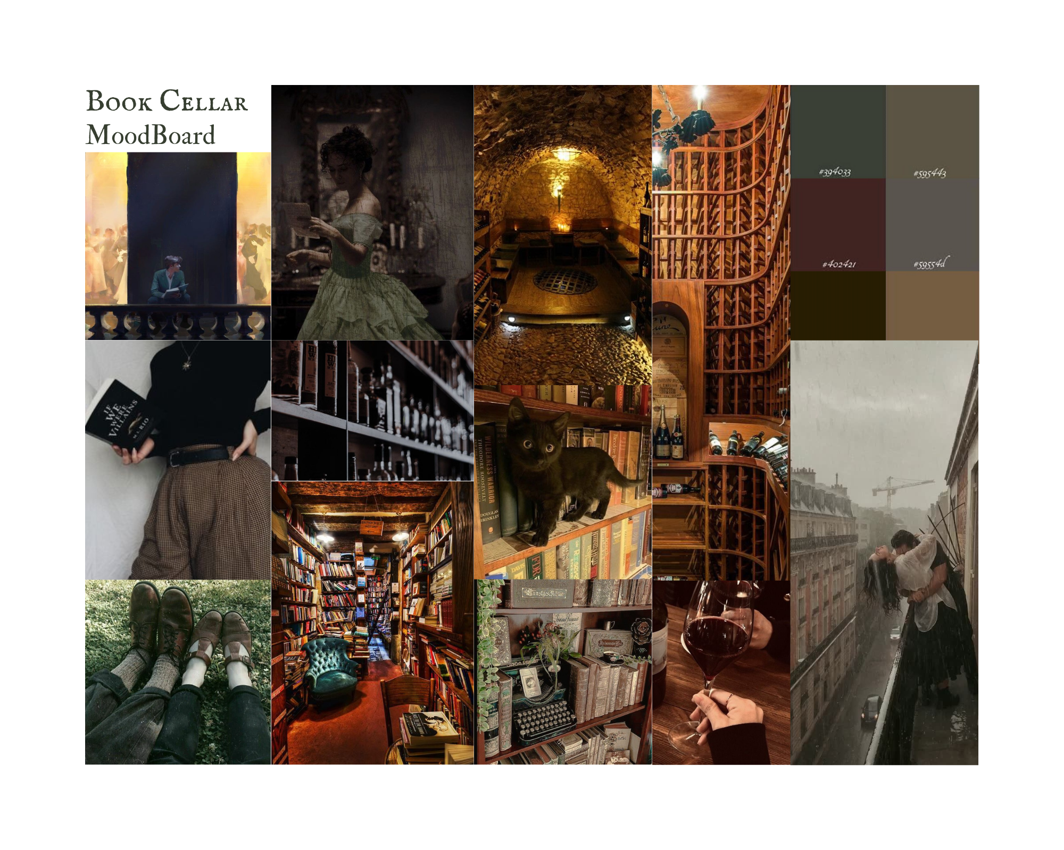

**CITATIONS**

*Global books market size & industry trends report* *2022 - 2030*. Global Books Market Size & Industry Trends Report, 2022 - 2030. (n.d.). Retrieved October 21, 2022, from https://www.grandviewresearch.com/industry-analysis/books-market

*Hot wine trends in the U.S. market for 2022, dollar sales up in 2021*. Dr. Liz Thach, MW. (2022, August 11). Retrieved October 21, 2022, from https://lizthachmw.com/winestars/hot-wine-trends-in-the-u-s-market-for-2022-dollar-sales-up-in-2021/

McCain, A. (2022, September 14). Wine Industry Statistics [2022]: Market trends, consumption statistics, and industry analysis. Zippia Wine Industry Statistics 2022 Market Trends Consumption Statistics And Industry Analysis Comments. Retrieved October 21, 2022, from https://www.zippia.com/advice/wine-industry-statistics/

Watson, A. (n.d.). Book readers in the U.S. by age 2021 | statista. Retrieved October 21, 2022, from https://www.statista.com/statistics/249787/book-reading-population-in-the-us-by-age/